**Codio Activity: Installing Docker Containers**

Install Docker:

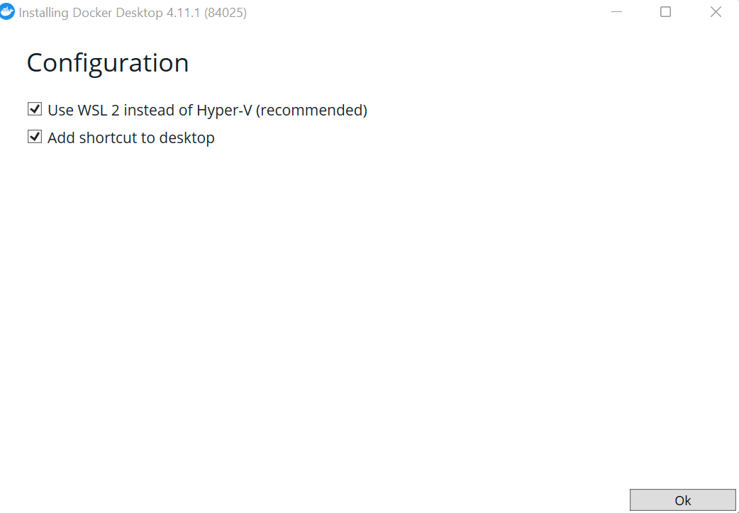

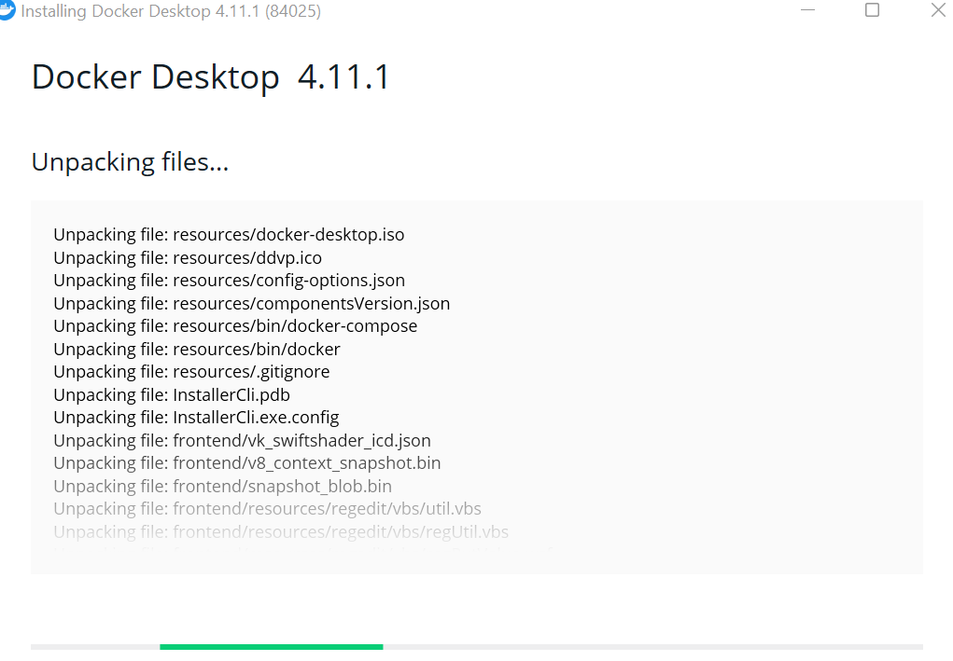

Required Virtual Box and Ubuntu

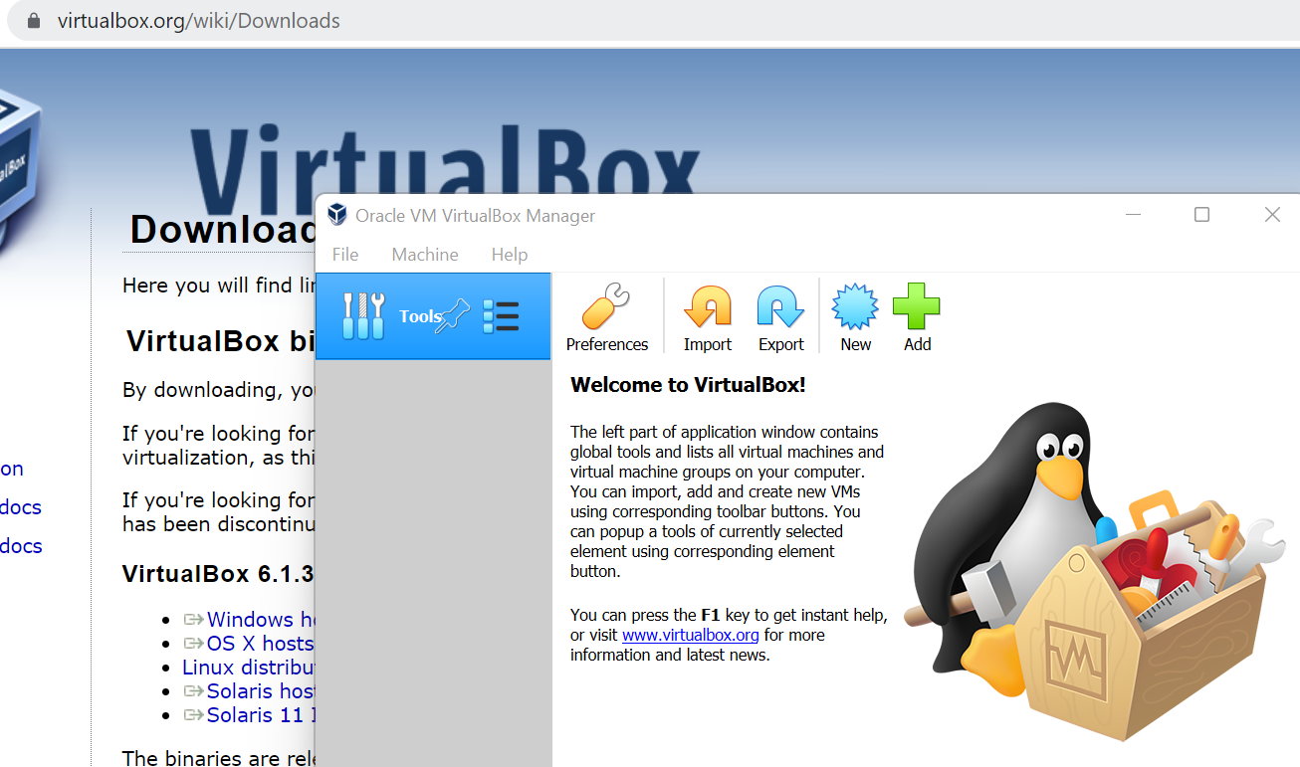

1. Perform a standard update to ensure you are using the latest libraries:

*sudo apt-get update*

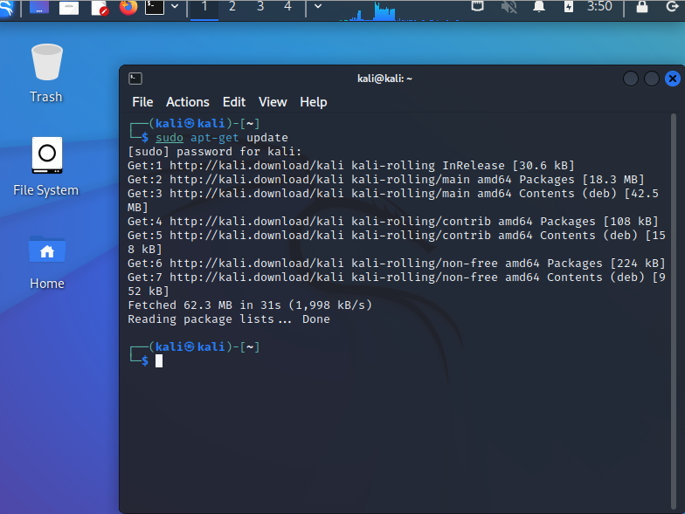

2. Install Docker from the standard repository:

*sudo apt install docker.io*

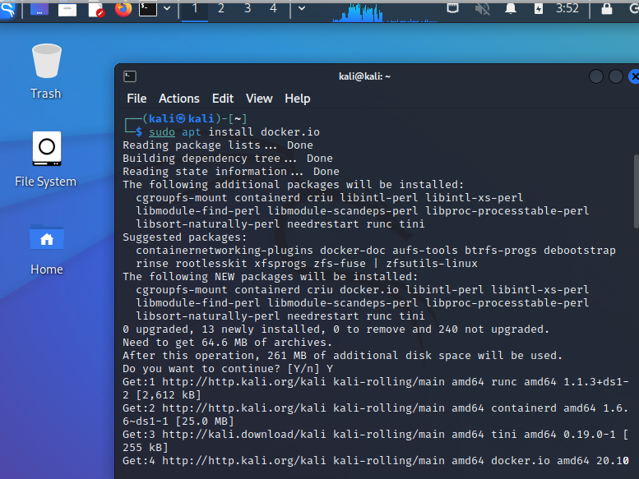

3. As part of the installation process, Docker will create a new group (called docker). You need to add your username to that group:

*sudo usermod -aG docker [ali]*

4. Log out and then back in to update your user status.

5. Check that you are a member of the docker group:

*id (produces the following output:*

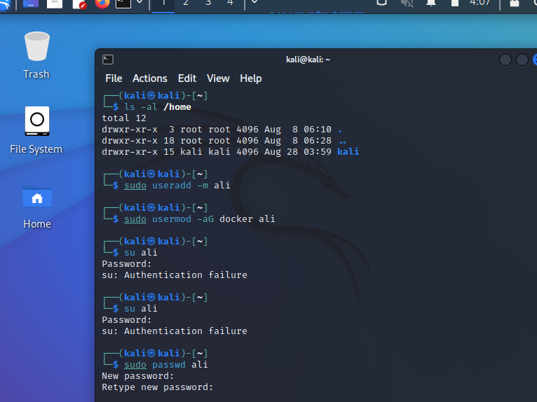

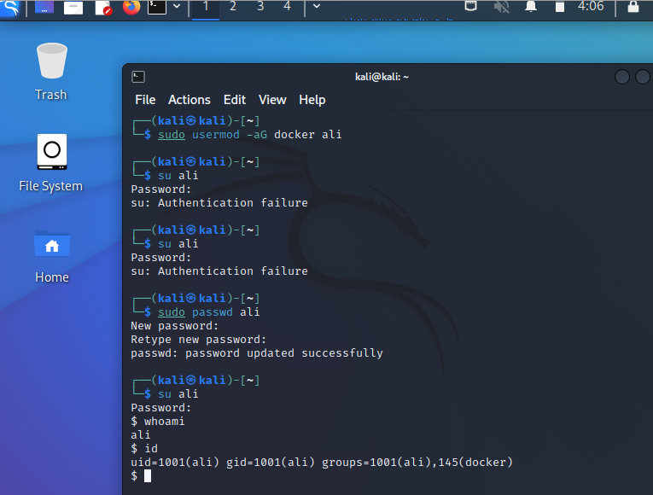

6. Issue the version command to check that docker is working properly:

*docker version (produces the output shown below:*

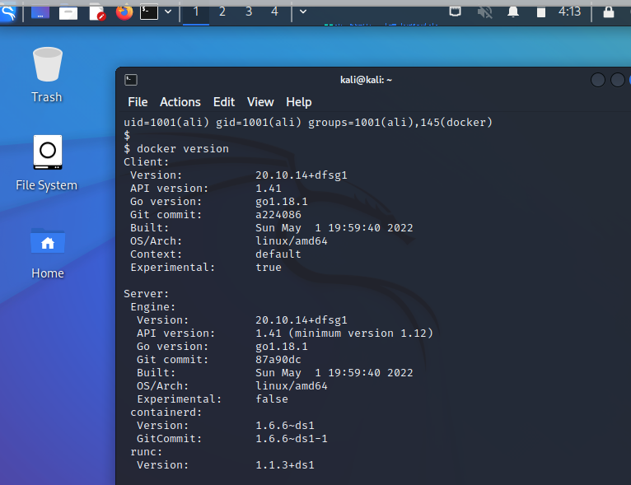

7. You can also run the “docker run hello-world" command to test a (very simple) container.

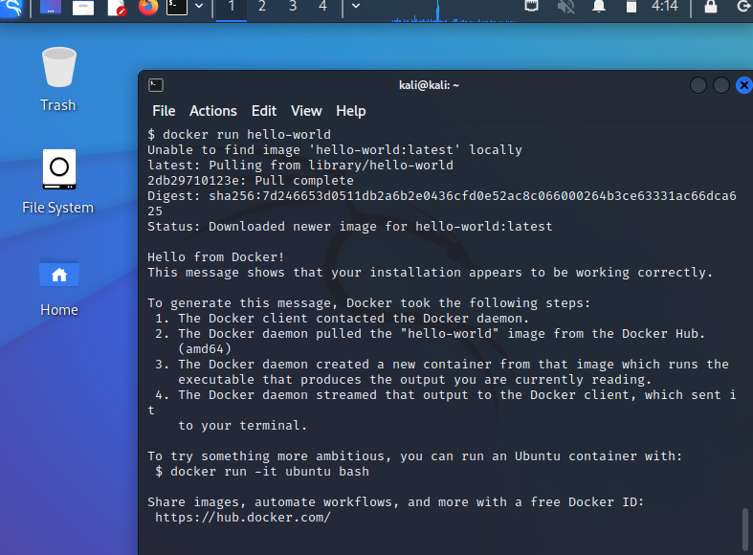

## Codio Activity: Socket Programming

## Copy the following code into a file named echo-server.py

## 

## Copy the following code into a file named echo-client.py

## 

Open a terminal. Start the server by running the following command in a terminal:

python3 echo-server.py

Open a second terminal. Start the client by running the following command in the terminal:

python3 echo-client.py

The client and server will now talk with one another.

## 

#### **Question 1**

In relation to echo-server.py, what is achieved using the command:

s.bind((HOST, PORT))?

making a Reverse Shell. and in the server.py file i got this error. i has trying in de socket_bind() s.bind((host, port))

#### **Question 2**

In relation to echo-server.py, what is achieved using the command:

s.connect((HOST, PORT))?

Used to connect to the remote socket with connect.

[**Codio Activity: Producer-Consumer Mechanism**](https://www.my-course.co.uk/mod/page/view.php?id=544784)

Producer/Consumer Problem (also known as the ‘bounded buffer’ problem):

* A ‘producer’ is producing items at a particular (unknown and sometimes unpredictable) rate.
* A ‘consumer’ is consuming the items – again, at some rate.

For example, a producer-consumer scenario models an application producing a listing that must be consumed by a printer process, as well as a keyboard handler producing a line of data that will be consumed by an application program. This is shown in the picture below (Shene, 2014).

Items are placed in a buffer when produced, so:

* Consumer should wait if there isn’t an item to consume
* Producer shouldn’t ‘overwrite’ an item in the buffer

Synchronisation is necessary because:

* If the consumer has not taken out the current value in the buffer, then the producer should not replace it with another.
* Similarly, the consumer should not consume the same value twice.

#### Task

Run producer-consumer.py in the provided Codio workspace (**Producer-Consumer Mechanism**), where the queue data structure is used.

A copy of the code is available here for you.

# code source: https://techmonger.github.io/55/producer-consumer-python/

from threading import Thread

from queue import Queue

q = Queue()

final_results = []

def producer():

for i in range(100):

q.put(i)

def consumer():

while True:

number = q.get()

result = (number, number**2)

final_results.append(result)

q.task_done()

for i in range(5):

t = Thread(target=consumer)

t.daemon = True

t.start()

producer()

q.join()

print (final_results)

Answer the following questions:

1. How is the queue data structure used to achieve the purpose of the code?
2. What is the purpose of q.put(I)?
3. What is achieved by q.get()?
4. What functionality is provided by q.join()?
5. Extend this producer-consumer code to make the producer-consumer scenario available in a secure way. What technique(s) would be appropriate to apply?